 

**Faculty of Technology and Engineering**

**Chandubhai S. Patel Institute of Technology**

**Department of Computer Science & Engineering**

|  |  |  |  |  |  |
| --- | --- | --- | --- | --- | --- |
| Project Group ID: | CSPIT/CSE/C2/ | Week No: 3 | | Date: -**30/12/2024 to 06/01/2025** | |
| Project Title: | HealthSync- Comprehensive Patient and Management System with Real-time Analysis | | | | |
| **Project Mentor:** | Dr.Jigar Sarda | | Academic Mentor: - | | Dr.Jigar Sarda |
| Name of Student:  (With Roll No) | D23CS102  Siddhit Kale | | D23CS104  Denis Ruparel | | D23CS108  Tanay Mahale |
| Weekly Objectives:  (2 Marks) | * Set up project repositories and integrate with GitHub for version control. * Setup Jira for task tracking. | | | | |
| Tasks Completed: (3 Marks) | * Created GitHub repository for documentation. * GitHub Link: *https://github.com/DenisRuparel/SGP_DOCs_6th_Sem.git* * Setup Jira boards for sprint tracking and backlog management. * Design the flow of data and process for the project. | | | | |
| Work Progress (3 Marks) | * Current Status: 10% Completed. | | | | |
| Challenges Faced | * Minor issues faces while setup in Jira. | | | | |
| Learnings and Skills Acquired (2 Marks) | * Gained a better understanding of Jira workflows and Git. | | | | |
| Plan for Next Week | * Set up continuous integration with Jenkins. * Create Dockerfiles for core services. | | | | |

Signatures of Students:

Siddhit Kale Denis Ruparel Tanay Mahale

(D23CS102) (D23CS104) (D23CS108)

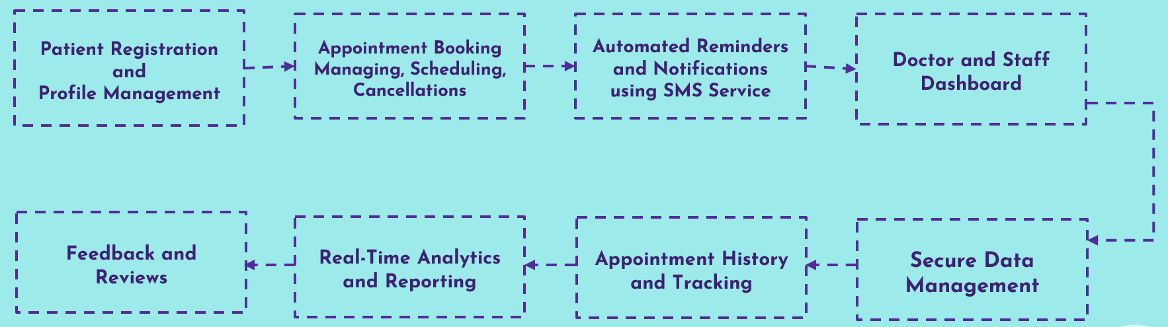

|  |  |
| --- | --- |
| Criteria | D23CS104 |
| Weekly Objectives (2 Marks) |  |
| Tasks Completed (3 Marks) |  |
| Work Progress (3 Marks) |  |
| Learnings and Skills (2 Marks) |  |
| Total (out of 10) |  |

**Mentor’s Comments:**

**Mentor’s Sign:**